Arduino UNO On/Off/KILL shield (kit)

For SMT or THT components

**Purpose**

This Open Source (GNU GPL 3.0) plug-in Arduino R3 UNO shield will control the underlying UNO‘s 5v power. The first button press switches it on. The second button press will inform the Arduino UNO to shut down. The Arduino can then do any housekeeping, such as closing files, logging data or sending an email.

The Arduino must respond that it is OK to shutdown via pin 2 (or pin 3, user-selectable) at which point the shield will kill the power. No power is used whilst switched off.

If the Arduino fails to respond then a manual, long press of the button will kill the power after a few seconds. You could change the code to automatically shut down after X seconds.

**Description**

The PCB has been designed to accept either SMD (Surface Mount Devices ) or THT(Through Hole Technology) components – or a mix and match approach. Just don’t fit the same part for both SMD and THT! The PSU part of the design (with standard input jack) is only SMD but you don’t have to use that. You can just use the three pin header instead.

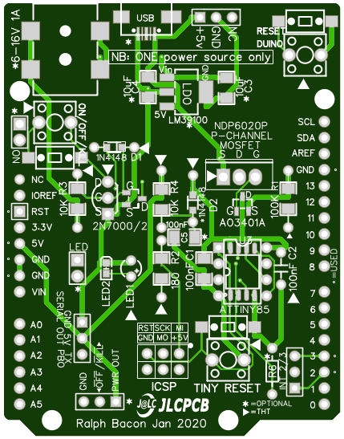 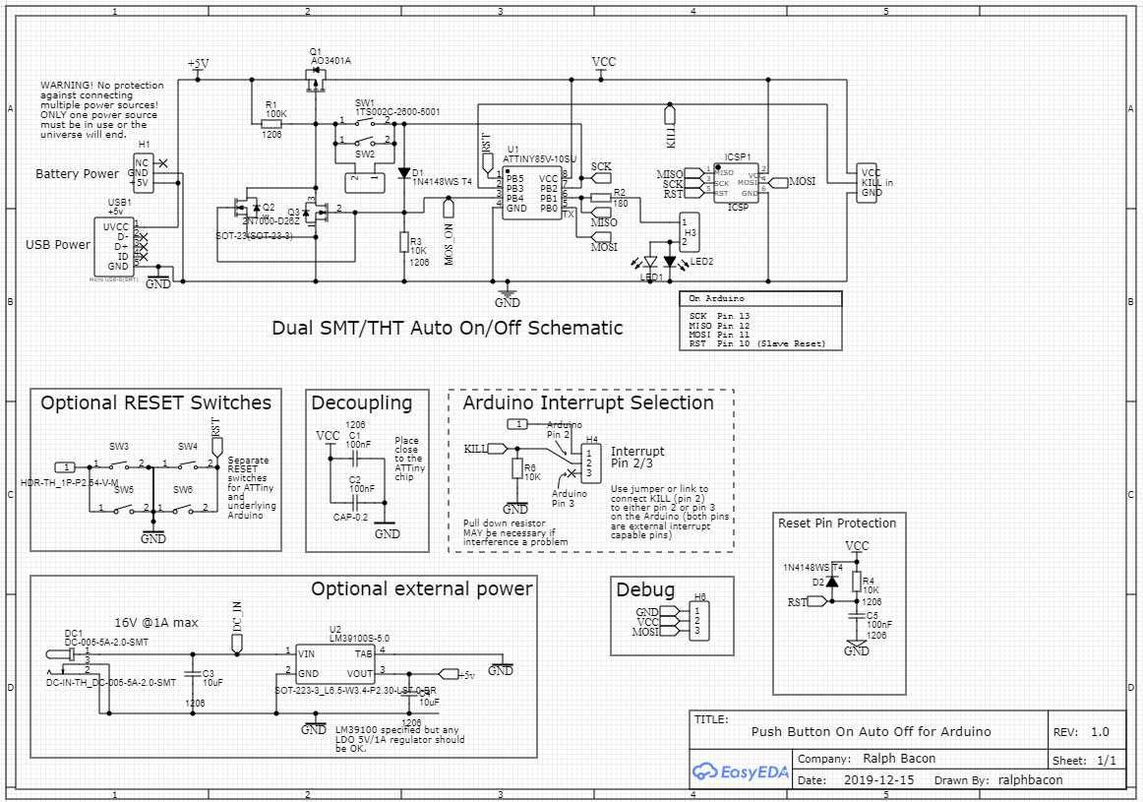

*Large versions of these documents can be found in my GitHub: https://github.com/ralphbacon*

The code for the ATTiny85 is open source (GNU/GPL 3.0) and can be found in my GitHub. An example Arduino UNO responder code snippet is also available there too. You would just add a couple of lines into your existing Arduino sketch to provide the functionality.

The PCB has been specifically designed to use (mainly) large, 1206 SMD components so that beginners to SMD can maximise their success rate. Some components remain small, however, and if considered above the skill of the assembler then through-hole alternatives can be used.

Optional components have been marked with an asterisk. These components do not have to be fitted for the circuit to work but may be fitted if required. For example, the ATTiny85’s RESET pin is not protected like the other pins. When fitted, D2, R4 and C5 protect the RESET pin in the same way as the others.

Through-hole components have been identified with a small triangle. Never fit both the TH component and the SMD equivalent.

The shield can use either pin 2 or pin 3 of the Arduino to communicate that a shutdown has been requested, and for the Arduino to send back an OK response. The PCB has the option to select either pin, either via header pins and a jumper or by hardwiring the required pin.

Serial (debugging) output is available via P0 of the ATTiny85. This is brought out to the 3-pin header H6 marked Serial Out PB0. Connect GND and TX to a USB-to-Serial device (eg FTDI) GND and RX pins to read the serial output on your PC’s Serial Monitor window. It uses a slim library called SendOnlySoftwareSerial written by Nick Gammon (from the Arduino original) to achieve this.

**Programming the ATTiny85**

Connect your programmer to the shield via the ICSP socket. Firstly burn the bootloader for an 8MHz internal clock ATTiny85, with BSD disabled, LTO enabled, Millis and Micros enabled, Arduino-as-ISP upload method.

Once the bootloader has been successfully applied you can upload the sketch in the same way. You could temporarily use your Arduino to program the ATTiny85 – just load the sketch under File > Examples > Arduino as ISP onto the Arduino.

Then connect the follow Arduino pins to the ICSP pins of the ATTiny85 shield:

|  |  |
| --- | --- |
| Shield ICSP | goes to Arduino Pin |
| VCC | VCC |
| GND | GND |
| SCK | 13 |
| MISO | 12 |
| MOSI | 11 |
| RST | 10 |

NB: You cannot keep the ICSP cable(s) connected to the shield as it will continue to supply power to the entire circuit even when the Tiny85 thinks it has killed the power.



**Do not handle the components without observing proper ESD protection practices.**

Why?

Because MOSFETs, in particular, are prone to being zapped (technical term) by careless handling.

Follow these simple (and cheap) rules:

1. Wear a grounded wrist-strap. These cost very little and connect from your wrist to the EARTH point in your house or on your workbench. Oscilloscopes often have a green terminal you can use. It ensures that YOU are not carrying a static charge, like the one you get when walking across a carpeted room in a dry environment. Ensure it has a 1MΩ strap resistor fitted so YOU don’t get zapped.
2. Don’t handle the MOSFETs (or any of the semiconductors, to be absolutely safe) until the time comes to fit them onto the PCB. But don’t fit these onto the PCB without other components being fitted *first* (eg especially resistors, which will help in dissipating any static).
3. Don’t pick semiconductors up with your hands. Use some ESD safe tweezers. Use the tweezers to pick them up gently by the body not the legs.
4. Ensure your soldering iron is ESD safe. Most modern irons will be safe, but if you are using something from the ark, then beware.

Finally, don’t panic about all the dire warnings. The universe will not implode if you touch a pin of a semiconductor. Just try and be sensible about it!

Components List

|  |  |  |  |  |  |
| --- | --- | --- | --- | --- | --- |
|  | **Description** |  | **QTY** | **Markings** | **See Note** |
| **Hardware** |  |  |  |  |  |
| USB socket | USB socket for PSU SMD only | Optional | 1 |  | 1 |
| DC1 | 7-16V input power jack SMD only | Optional | 1 |  |  |
| SW1 – SW6 | Push Button Switch SMD / THT |  | 6 |  | 2 |
| H1, H2, H4, H6 | 3-pin header | Optional | 4 |  | 3 |
| H3, H5 | Two pin header | Optional | Use a spare cut-down 3-pin | | |
| ICSP1 | 2x3-pin male connector ICSP header |  | 1 |  |  |
| PCB | JLCPCB dual SMD/THT - designed by Benny |  | 1 |  | 4 |
|  |  |  |  |  |  |
| **Components** |  |  |  |  |  |
| R1 | 100KΩ SMD 1206 / THT  (You may get a 82KΩ THT Gr Rd Yl) |  | 1 | 1003 / Br Bl Yl | 5 |
| R2 | 180Ω SMD/THT |  | 1 | 1800 / Br Bl Br |  |
| R3 | 10KΩ Resistor SMD **0805** /THT |  | 1 | 103 / Br Bl Or | 6 |
| C1, C2 | 100nF capacitor 1206 SMD/THT |  | 2 | No markings. 10µF are larger |  |
| C3, C4 | 10µF capacitors 1206 SMD only for PSU (larger than C1/C2) |  | 2 |  |
| LED1, LED2 | Red or Green LED 0603 SMD/THT |  | 2 | Use multimeter to determine orientation | 7 |
| N/A | Jumper (or use a link) |  | 1 |  |  |
| U1 | ATTiny85 SOIC/DIP-8 SMD/THT |  | **NONE** |  | **8** |
| N/A | 8-pin DIP socket | Optional | **?** | **Difficult to pack** | **9** |
| R4 | RESET pin protection | Optional | **NONE** |  | **10** |
| R6 | 10KΩ Resistor reduce interference susceptibility | Optional | **NONE** |  |
| C5 | RESET pin protection | Optional | **NONE** |  |
| D2 | RESET pin protection | Optional | **NONE** |  |
|  |  |  |  |  |  |
| **Semi-conductors** |  |  |  |  |  |
| Q1 | A03401A SMD P-channel MOSFET |  | 1 | X14X12 | 11 |
| Q1 | NDP6020P THT P-channel MOSFET (high power) |  | **NONE** | **Too expensive** | **13** |
| Q2 | 2N7000 THT N-channel MOSFET |  | 1 | 2N7000 |  |
| Q2 | 2N7002 SMD N-channel MOSFET |  | 1 | 7002 | 11 |
| D1 | 1N4001 (or similar) Diode SMD / THT |  | 1 | T4 / No marking |  |
| U2 | LM39100S 5v regulator SMD only  (If you have a LM1117V5 it will work too) |  | 1 | 39100 | 12 |

I recommend you check each component’s value and orientation before soldering!

NOTES

1. Fitting the USB socket is tricky if you have never done it before. Solder can get *inside* the socket and prevent the plug being inserted. I recommend you fit the Barrel Jack.

2. You should have 3 switches of each type. They SMD ones are easy to fit, with jut lug-type feet.

3. I didn’t have any two-pin headers so just use one fo the 3-pin ones resized for the LED two-pin header (or use a link for that header if you always want the LED to light up. You can change the code so that it stays OFF until shutdown is in progress (flashing).

4. Read the Errata sheet regarding the PCB. Benny sends his apologies for the two mistakes.

5. You may have an 82KΩ resistor instead of a 100KΩ through-hole component, works the same.

6. The 10KΩ resistor is only 0805 sized not 1206.

7. The LEDs are specks-of-dust 0603 devices. If you can’t solder them use the through hole ones.

8. I couldn’t get any ATTiny85s (at a cheap enough price from LCSC) so you will have to supply your own. recommend the 8-pin DIP version.

9. At time of writing I don’t know whether an IC socket will fit into the packet without puncturing it (or getting bent pins. If there is none then you will have to supply your own (or solder the IC directly – watch the orientation).

10. It’s unlikely you will need RESET pin protection but if you do then there is room to install them.

11. The small ICs are easier to solder than you might think as they only have 3 pins.

12. the 5v regulator is easy to solder. Ensure you solder the tab to GND.

13. Sorry, but P-channel, through-hole MOSFETs are not cheap (50p - £1.50) and LCSC didn’t sell the one I specified (and used in my demo). If you really need a through-hole component you can get something from eBay, Banggood or AliExpress at a reasonable price. Try soldering the SMD version instead, it allows 4A current, yes, really!

You may have a component missing. Benny is sorry about this. He did his best. You may also have some components duplicated (SMDs mainly) so that when (not if) it flies across your table onto the floor, never to be seen again, you have another shot at getting it soldered).

ERRATA

Benny made a couple of mistakes in the PCB design. He’s very sorry about this.

1. The **through-hole** D1 cathode is not connected to the SMT pad (see photo left)

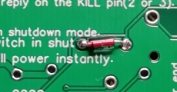 The best way to solder the 1N4001 diode is to fit the through-hole diode from *underneath* the board (photo right) so the wires come through the top and bend the cathode wire over to the SMT pad and solder it there (as well as the through hole, if you want).

Bottom view with the diode soldered from the top. Note the *cathode* (black ring) is towards the left of the diode body here.

The soldered wire from the SMD pad to the THT hole is shown arrowed in the left photo. None of this is applicable if you solder the SMD diode instead.

2. The ATTiny85 SMD footprint is incorrect and is for a slightly narrower version of the chip. However, if you push the legs of the SMT chip closer to the chip body it is relatively easy to solder, just about. I’ve done it twice with my dodgy eye so I reckon others can do it too. Otherwise just use a through hole DIP version of the chip (with an optional 8-pin DIP IC socket).

Useful links

My GitHub with links to the YouTube video, sketches, photos… you get the idea.

https://www.github.com/ralphbacon

SendOnlySoftwareSerial

https://github.com/nickgammon/SendOnlySoftwareSerial